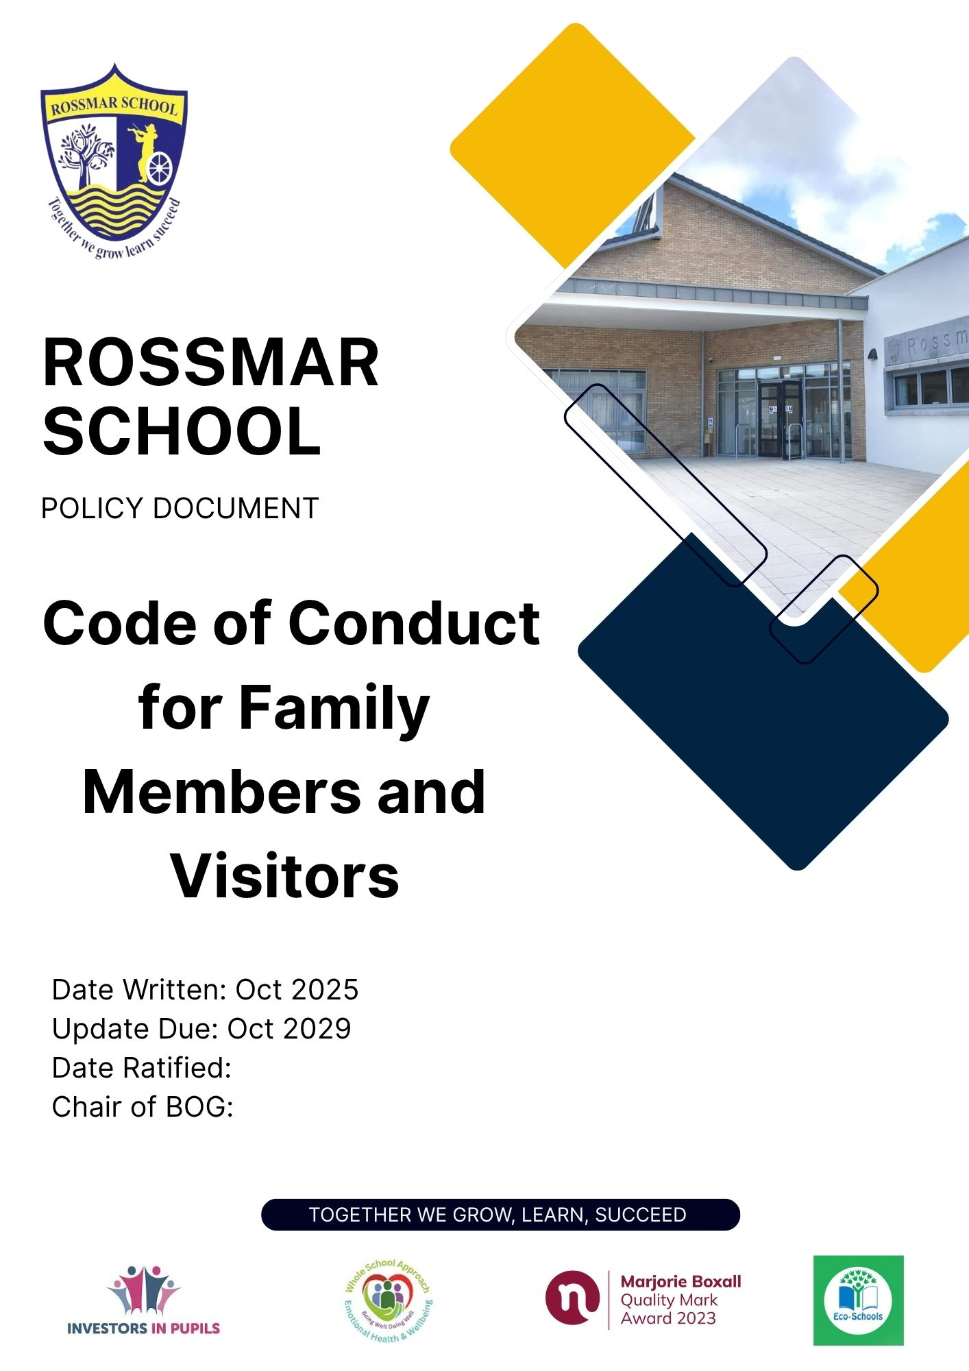

Rationale

In Rossmar School we are endeavouring to create an environment where all who enter are treated with respect and dignity. The health, safety and well-being of our pupils, staff and volunteers are of paramount importance. Family members and visitors can also expect to experience a welcoming and supportive ethos and environment where they feel respected and valued when they visit.

In the best interests of all the following code has been devised:

Guidance:

We expect family members and visitors to:

- Respect our school values and our caring ethos.
- Understand that both staff and family members need to work together for the benefit of their children.
- Demonstrate that all members of the school community should be treated with respect and therefore set a good example in their own speech and behaviour.
- Seek to clarify a child’s version of events with the school’s view to bring about a peaceful solution to any issue.
- Approach the school to help resolve any issues of concern.
- Avoid using staff as threats to admonish child’s behaviour.
- Refrain from using mobile phones in areas where pupils are or could be present.
- Supervise your own child while you are with them in the school or grounds.

Protocol and procedures:

All visitors must report to reception. All visitors must wear a visitors’ badge and sign the Visitors Record Book which is kept in reception at all times making note of their name, organisation, who they are visiting, car registration.
Visitors will then be escorted to their point of contact OR their point of contact will be asked to come to reception for their visitor.
Parents who are entering the school for a meeting will be asked sign and out for meetings.

Unacceptable Behaviour:

Everyone who enters Rossmar school, pupils, staff, governors and visitors should be treated with respect and courtesy.
To support a peaceful and safe school environment the school cannot tolerate family members and visitors exhibiting the following:

- Disruptive behaviour which interferes or threatens to interfere with the operation of the school in any area of the building or grounds.
- Using loud/or offensive language, swearing, cursing, using profane language or displaying temper.
- Threatening to do actual bodily harm to a member of school staff, Governor, visitor, fellow parent/ carer or pupil.
- Damaging or destroying school property
- Abusive or threatening emails or text/voicemail/phone messages or other written communication.
- Defamatory, offensive or derogatory comments regarding the school or any of the pupils’/parents’/ staff, at the school on Facebook or other social sites.

The Principal or a Senior Leader will seek to interject in the situation and speak to the visitor.

Dealing with your concerns:

At Rossmar school we value parents/carers as partners in the education of our pupils. The views of parents are appreciated, and we encourage the positive contributions which parents make to the life of the school.

From time to time, a parent/carer may have a concern about some aspect of their child’s life at school. It is the school’s aim that any concern is dealt with quickly and efficiently, to the satisfaction of all. Any concerns you may have about the school must be made through the appropriate channels by speaking to the class teacher, Head of Department, Vice Principal, Principal or the Chair of the Governors, so they can be dealt with fairly, appropriately and effectively for all concerned.

I have a concern, what should I do? I have a concern about: | I should:
my child’s progress in school or behaviour | make an appointment to see my child’s class teacher to discuss my concerns. If I am still concerned, then I should make an appointment to see the Head of Key Stage, responsible for your child’s year group or Head of Curriculum Mrs Shaw or Mrs Clements
a child, or my child’s safety or welfare | contact Mrs McCallion Head of Pastoral Care or Vice Principal Miss Fisher Designated Teacher for Child Protection, or in their absence the Principal Mrs Clements
a member of staff | make an appointment to meet with Mrs Clements to discuss my concern.
the principal | contact the Chair of Governors Mrs Heather Pratt by writing to her at the school address

Visitors’ departure from school:
On departing the school, visitors MUST leave via reception and:
- Enter their departure time in the visitors record book alongside their arrival entry.
- Return their visitors badge to reception.

Board of Governors will monitor and evaluate the effectiveness of this policy as part of a timetabled, on-going process.

